Architecture Layer in API:
The primary layers involved are:
- Presentation Layer (API Layer/Controller Layer):
  - This is the entry point for client requests (e.g., web browsers, mobile apps).
  - In a .NET API, this typically involves Controllers that handle HTTP requests, route them to the appropriate business logic, and return responses (e.g., JSON, XML).
  - It focuses on exposing endpoints and handling request/response serialization/deserialization.
- Business Logic Layer (BLL) / Service Layer:
  - This layer contains the core business rules, validations, and application logic.
  - It orchestrates the flow of data, performs calculations, and enforces business policies.
  - It acts as an intermediary between the Presentation Layer and the Data Access Layer, ensuring data integrity and consistency.
- Data Access Layer (DAL) / Repository Layer:
  - This layer is responsible for interacting with the data source (e.g., database, external APIs, file system).
  - It abstracts the details of data persistence, providing a clear interface for the Business Logic Layer to perform CRUD (Create, Read, Update, Delete) operations without knowing the underlying data storage mechanism.
Additional Layers (Optional but common)
- Application Layer:
In more complex scenarios, an Application Layer might sit between the Presentation and Business Logic Layers. It coordinates application-specific workflows, handles transactions, and might integrate with external services.
- Domain Layer:
This layer defines the core entities, value objects, and domain services that represent the business domain. It's often used in Domain-Driven Design (DDD) to encapsulate business logic within the domain models themselves.
- Shared/Infrastructure Layer:
This layer can contain common utilities, helper methods, cross-cutting concerns (like logging or error handling), and infrastructure-related services that are utilized across multiple layers.
https://www.geeksforgeeks.org/node-js/what-makes-an-api-restful/

How to Secure Web API:
Implement below Technique:

1. Authentication and Authorization
- Authentication: Verifies the user's identity.
- Authorization: Determines what actions the authenticated user is allowed to perform.

2. Input Validation and Data Protection
- Input Validation & Sanitization: Crucial to prevent injection attacks like SQL injection or cross-site scripting (XSS).
  - Use Data Annotations on your models to enforce validation rules.
  - Implement custom validation logic for complex cases.
  - Sanitize inputs before storing or displaying them to prevent XSS
- HTTPS (TLS) for Encryption: Essential for encrypting data in transit, protecting sensitive data from interception.
  - Use app.UseHttpsRedirection() in your Startup.cs to automatically redirect HTTP requests to HTTPS.
- Secure Secrets Management: Never hardcode sensitive information like API keys or connection strings.
  - Use environment variables or a secure configuration provider for local development.
  - Leverage cloud-native solutions like Azure Key Vault or AWS Secrets Manager for production environments.

3. Other crucial security measures
- Rate Limiting: Protect your API from brute-force attacks by restricting the number of requests a client can make within a certain timeframe. Libraries like AspNetCoreRateLimit can help with implementation.
- Cross-Origin Resource Sharing (CORS): Control which domains are allowed to access your API to prevent unauthorized cross-origin requests. Configure CORS policies to restrict API access to specific origins, according to Medium.
- Security Headers: Utilize HTTP response headers to provide browser instructions that mitigate attacks like XSS or clickjacking, according to Medium.
- Logging & Monitoring: Implement robust logging and monitoring to detect and respond to security incidents.
- Regular Updates & Patching: Keep your .NET Core packages and third-party dependencies updated to benefit from the latest security patches.
- Security Testing: Conduct regular vulnerability assessments, penetration testing, and code reviews to identify and fix security flaws.
In Short:

How do you secure ASP.NET Core Applications?
Securing ASP.NET Core applications involves multiple strategies, including:
- Implementing authentication and authorization (e.g., using ASP.NET Core Identity).
- Using HTTPS to encrypt data in transit.
- Implementing data protection to secure sensitive data.
- Using anti-forgery tokens to prevent Cross-Site Request Forgery (CSRF) attacks.
- Validating and sanitizing input to prevent Cross-Site Scripting (XSS) attacks.

Return type of web api:

1. IActionResult or ActionResult
- Description: These are flexible return types that allow you to return various HTTP responses (e.g., Ok, NotFound, BadRequest).

2. Specific Types (e.g., string, int, List<T>, CustomModel)
- Description: You can return a specific type directly, which will be serialized into JSON or XML (depending on the client's request).

3. ActionResult<T>
- Description: Combines the flexibility of IActionResult with the type safety of returning a specific type.

4. Task or Task<T> (Asynchronous)
- Description: Used for asynchronous operations, returning either Task or Task<T>.
5.JSONResult, EmptyResult, FileResult.

Difference between IActionResult and ActionResult:
IActionResult:
1)IActionResult is an interface defining a contract for action results, allowing for custom result types and greater code flexibility.

2)It offers maximum flexibility, allowing you to return various types of results (e.g., ViewResult, JsonResult, RedirectResult, FileResult, NotFoundResult, OkResult, BadRequestResult, etc.) from a single action method based on different conditions.

ActionResult:
1)ActionResult is an abstract class in ASP.NET Core MVC, serving as a base for built-in result types. And inherits from IActionResult.

2)It's used when you want to return a specific type of structured data (T) along with an HTTP status code. For example, ActionResult<Product> would indicate that the action returns either a Product object or an ActionResult like NotFound().

Difference between generic and non-generic collections in C#

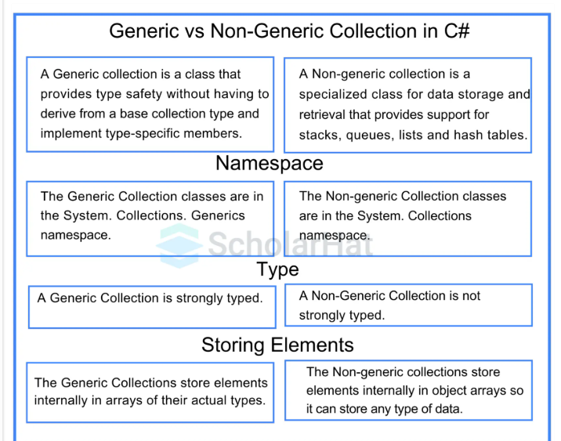

Generic Collections Examples:
List<T>, Dictionary<TKey, TValue>, Stack<T>, Queue<T>, HashSet<T>.

Non-Generic Collections Examples:
ArrayList, Hashtable, SortedList, Stack, Queue.

Azure AD authentication:
https://www.youtube.com/watch?v=pS1hER46PQI&t=186s

Difference between Abstraction and Encapsulation:
Abstraction | Encapsulation
Abstraction solves the problem at the design level. | Encapsulation solves the problem in the implementation  level.
Abstraction is used for hiding unwanted data and giving only relevant data. | Encapsulation is hiding the code and data into a  single unit to protect the data from the outer world.
Abstraction is set to focus on the object instead of how it does it. | Encapsulation means hiding the internal details or  mechanics of how an object does something.
Abstraction is the outer layout in terms of design. For Example: the outer Look of an iPhone, is like it has a display screen. | Encapsulation is the inner layout in terms of  implementation. For Example: - Inner Implementation  detail of an iPhone, how Display Screen are  connected with each other using circuits.

Difference between override and new Keyword:
- Polymorphism:
override enables polymorphism; new does not.
- Base Class Member Requirement:
override requires the base class member to be virtual or abstract; new does not.
- Behavior with Base Class Reference:
With override, the derived class's implementation is called; with new, the base class's implementation is called.
- Purpose:
override extends or modifies a base class implementation; new hides it with a new, independent implementation.

Content Negotiation Definition:

We can define Content Negotiation as

“the process of selecting the best representation for a given response when multiple representations are available”.

How are Content Negotiations handled?
Accept and Content-Type are the two HTTP headers that are mainly involved in content negotiation.

1)Accept Header: The client uses this field to indicate the kinds of media that it is ready, willing, and able to handle. To specify whether a client wants to receive data in the XML (application/xml) or JSON (application/json) formats, for example, the client can use the Accept header.
2)Content-Type Header: The server uses the Content-Type Header to indicate the media type of the response content that it is sending back to the client. It guarantees that the client is capable of parsing and processing the received data by informing them of the format in which the response data is encoded.

CORS:

Cross-Origin Resource Sharing (CORS) is a security mechanism implemented by web browsers that restricts web pages from making requests to a different domain than the one that served the web page. This prevents malicious scripts from accessing resources on other sites without explicit permission.
How to Use CORS
- Enable CORS Middleware: In ASP.NET Core, CORS is typically enabled by configuring the CORS middleware in the Startup.cs file.
Code
public void ConfigureServices(IServiceCollection services)
{
services.AddCors(options =>
{
options.AddDefaultPolicy(builder =>
{
builder.WithOrigins("http://localhost:4200") // Replace with your allowed origin(s)
.AllowAnyHeader()
.AllowAnyMethod();
});
// Add other named policies here
});
services.AddControllers();
}
public void Configure(IApplicationBuilder app, IWebHostEnvironment env)
{
app.UseRouting();
app.UseCors(); // Place after UseRouting and before UseAuthorization
app.UseAuthorization();
app.UseEndpoints(endpoints =>
{
endpoints.MapControllers();
});
}

Creating Different Policies
Named CORS policies can be created within the AddCors method to define specific rules for different scenarios.
Code
services.AddCors(options =>
{
options.AddPolicy("SpecificOriginsPolicy", builder =>
{
builder.WithOrigins("http://example.com", "http://anotherdomain.com")
.WithMethods("GET", "POST")
.WithHeaders("Content-Type", "Authorization");
});
options.AddPolicy("AllowAllPolicy", builder =>
{
builder.AllowAnyOrigin()
.AllowAnyMethod()
.AllowAnyHeader();
});
});
How CORS Works with Default and Controller-Level Policies
- Default Policy:
  - The AddDefaultPolicy method in AddCors defines a global default policy that applies to all endpoints unless overridden.
  - This policy is applied when app.UseCors() is called without a specific policy name.
- Controller-Level Policy:
  - The [EnableCors] attribute can be applied to a controller or an action method to apply a specific CORS policy.
  - If [EnableCors] is used without a policy name, it will apply the default CORS policy defined in AddDefaultPolicy.
  - To apply a named policy, the [EnableCors] attribute is used with the Policy property set to the desired policy name.
Code
[EnableCors("SpecificOriginsPolicy")] // Applies the "SpecificOriginsPolicy"
public class MyController : ControllerBase
{
// ...
}
[EnableCors] // Applies the default policy
public class AnotherController : ControllerBase
{
// ...
}
- Precedence:
  - CORS policies are applied with a hierarchy: action-level policy > controller-level policy > global default policy.
  - If a more specific policy (e.g., at the action level) exists, it overrides any less specific policies (e.g., controller-level or global default).
  - The [DisableCors] attribute can be used to explicitly disable CORS for a specific controller or action, even if a global or controller-level policy would otherwise apply.

Exception Handling:
While the try-catch block is the standard and most direct way to handle exceptions in C#, there are alternative approaches, particularly in modern .NET applications, to achieve centralized exception handling without explicitly writing try-catch blocks in every method:
- Centralized Exception Handling with Middleware (ASP.NET Core):
In ASP.NET Core applications, you can leverage middleware to handle exceptions globally. This approach allows you to catch exceptions that occur anywhere in the request pipeline and perform actions like logging, returning a standardized error response, or redirecting.
Code
public void Configure(IApplicationBuilder app, IWebHostEnvironment env)
{
if (env.IsDevelopment())
{
app.UseDeveloperExceptionPage();
}
else
{
app.UseExceptionHandler("/Error"); // Redirects to a specific error page/controller
}
// ... other middleware
app.UseRouting();
app.UseAuthorization();
app.UseEndpoints(endpoints =>
{
endpoints.MapControllers();
});
}

Deployment:

How do you deploy ASP.NET Core applications?
Deploying ASP.NET Core applications can be done in several ways, including:
- To a web server, like IIS, using Web Deploy or FTP.
- To cloud services, like Azure App Service, directly from Visual Studio or using CI/CD pipelines.
- Using containers, deploying as a Docker container to a container orchestration service like Kubernetes.
- Creating self-contained deployments (SCD) or framework-dependent deployments (FDD) for hosting on any platform that supports .NET.

What are some deployment options available for ASP.NET Core?
- IIS (Internet Information Services): A flexible, secure, and manageable Web server for hosting anything on the Web.
- Kestrel: A cross-platform web server for ASP.NET Core.
- Docker Containers: Package applications with all of their dependencies and services.
- Cloud Services: Azure App Service, AWS Elastic Beanstalk, and Google Cloud App Engine are popular cloud hosting options.
- Linux or Windows Virtual Machines: For full control over the hosting environment.

Explain the role of Docker and Kubernetes in ASP.NET Core deployment.
- Docker: Provides a way to package ASP.NET Core applications with all their dependencies into containers, ensuring consistency across environments and simplifying deployment.
- Kubernetes: An orchestration tool for Docker containers, managing aspects like scaling, load balancing, and self-healing of containers in cluster environments, facilitating microservices architecture.

How do you implement continuous integration and continuous deployment (CI/CD) pipelines for ASP.NET Core?
Utilize tools like Azure DevOps, Jenkins, or GitHub Actions to automate the build, test, and deployment process of ASP.NET Core applications.

Set up pipelines to include steps for code compilation, running tests, and deploying to various environments (development, staging, production) based on triggers like code commits or manual approvals.

Session in Web api

Session in ASP.NET Core MVC .NET 8

How to Enable Session in .Net 8 Asp.Net Core MVC Application?

builder.Services.AddSession();
C#
Add another line just after app declaration line:

app.UseSession();
C#
How to set or store the value in session?
Create or Setting Session value.

Syntax

HttpContext.Session.SetString(KEY,VALUE);

HttpContext.Session.SetInt22(KEY,VALUE);
C#
Example

HttpContext.Session.SetString(“USERNAME”, UserName);

HttpContext.Session.SetString(“USERID”,Convert.ToString(UserID));
C#
How to get or retrieve the value of session?
Getting Session value.

Syntax

HttpContext.Session.GetString(KEY);

HttpContext.Session.GetInt22(KEY);
C#
Example

HttpContext.Session.GetString(“USERNAME”);

HttpContext.Session.GetString(“USERID”);
C#
How to remove particular session key?
You can easily remove a specific session key.

Syntax

HttpContext.Session.Remove(KEY);
C#
Example

HttpContext.Session.Remove(“UESERNAME”);
C#
How to remove all session keys?
You can delete/remove/clear all sessions in one go.

HttpContext.Session.Clear();
C#
Clear: It remove all the current session entries from the server.

OR

HttpContext.SignOutAsync();
C#
SignOutAsync: It end the current user session and remove or clear the user’s authentication cookie from the server.

IApplicationBuilder:
IApplicationBuilder is a crucial interface in ASP.NET Core used to configure the application's HTTP request pipeline by adding middleware components.
The order in which middleware components are added to the pipeline is important, as it defines the order in which they handle requests and responses.
Key Uses and Methods
- Configuring Middleware: The primary use of IApplicationBuilder is to define how the application responds to HTTP requests by chaining together various middleware components.
- Defining the Request Pipeline: The host (or WebApplication instance) creates an IApplicationBuilder and passes it to the Configure method (in Startup.cs for older .NET versions) or uses it directly in the Program.cs file (in modern .NET versions) to set up the pipeline.
Key methods provided by the interface include:
- Use(): This extension method adds a middleware delegate to the pipeline and allows it to call the next middleware component in the sequence. It's used for components that perform operations before and after calling the next delegate (e.g., logging, authentication).
- Run(): This method adds a terminal middleware delegate that short-circuits the pipeline and does not call a next function. It's often used for simple, inline responses.
- Map(): This method is used to branch the request pipeline based on a matching request path, allowing different middleware pipelines for different URL paths.
- Build(): This method builds the final RequestDelegate that the application uses to process HTTP requests.

Custom Middleware:
https://www.tutorialsteacher.com/core/how-to-add-custom-middleware-aspnet-core

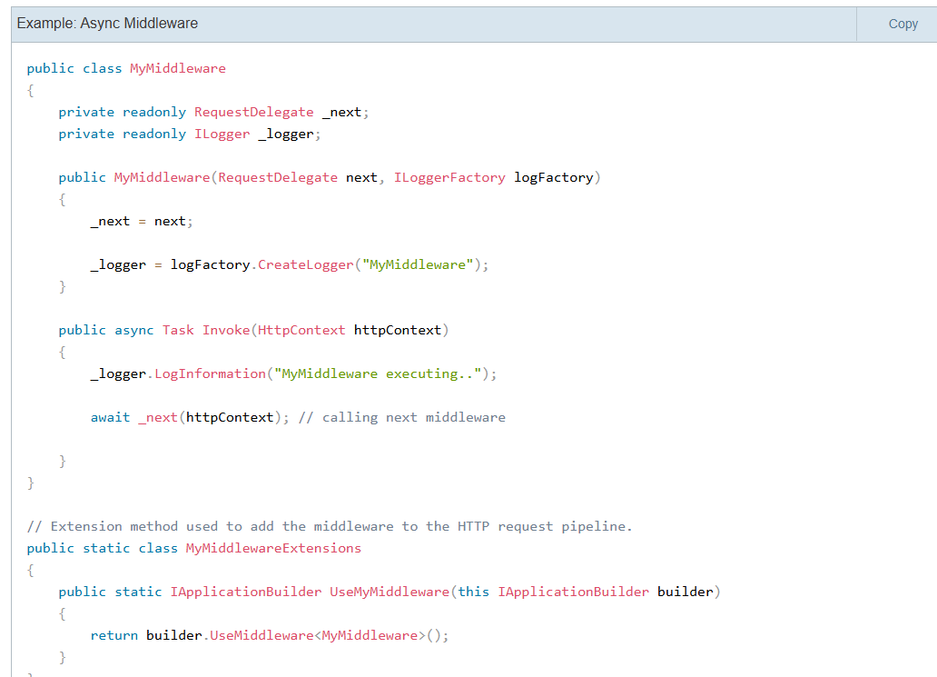

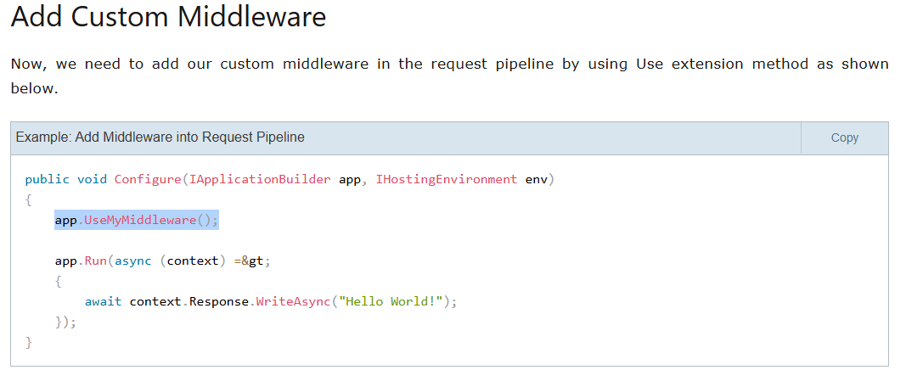

Request & Response Body Logging in ASP.NET Core | ByteCrafted
1)Request Method
context.Request.Body

context.Request.Method

context.Request.Path
context.Request.Headers

2)Response Method
context.Response.Body

context.Response.StatusCode

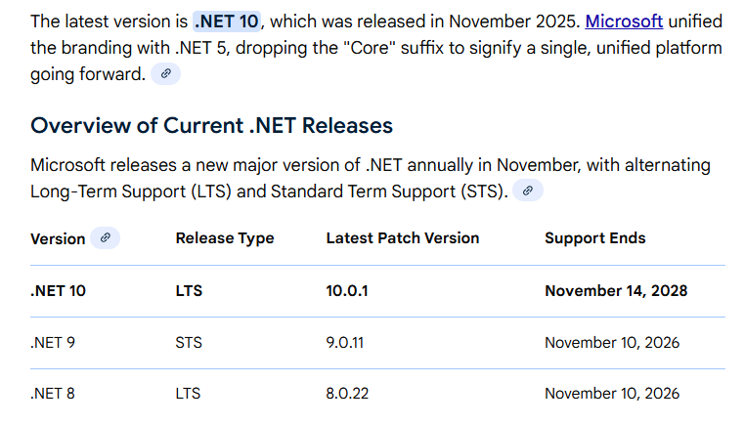

Explain Cross-Site Request Forgery (XSRF) and how to prevent it in ASP.NET Core applications.
XSRF (Cross-Site Request Forgery), also known as CSRF, is a web security vulnerability that tricks a user's browser into performing an unauthorized action on a trusted website. The attacker achieves this by exploiting the browser's automatic sending of cookies and trust in the website.

Preventing XSRF in ASP.NET Core:
There are several ways to prevent XSRF attacks:
- Anti-forgery tokens: Unique token in requests blocks unauthorized actions.
- Double-submit cookies: Flag-in cookies ensure intended form submission.
- SameSite attribute: Restricts cookie scope to mitigate XSRF risk.
- HTTP methods: PUT/DELETE require user interaction, preventing link-triggered attacks.
- Validate user input: Always sanitize to prevent data manipulation.

